­

20200

Submitted on: 14-12-2020

Submitted to: Mam Behjat zuhaira

Programming

Fundamentals

LAB ASSIGNMENT #3

|  |
| --- |
| Submitted by: |
| **Muhammad Saqib**  **Sp20-BSE-069** |
|  |
|  |

**Q – 1. Write recursive implementation for the following problems.**

1. Suppose you are at some height above sea level. Now you want to come down, to the ground, that is at the sea level. Solve this recursively. When you are halfway, display the message, “You are halfway down!”.

package com.company;  
import java.util.Scanner;  
public class Q1_a {  
  
 public static String height(int h , int b){  
 if(h==b){  
 return ("At " + h +"meter You are halfway down! ");}  
 else  
 return *height*(h-1,b);  
 }  
  
 public static void main(String[] args){  
 Scanner sc = new Scanner(System.*in*);  
 System.*out*.println("For an observer standing on the ground with h=2 metres \n" +  
 "Enter your current height: ");  
 int h = sc.nextInt();  
 int b=h/2;  
 System.*out*.println("Message is \n " + *height*(h,b));  
 }  
}

**Output:-**

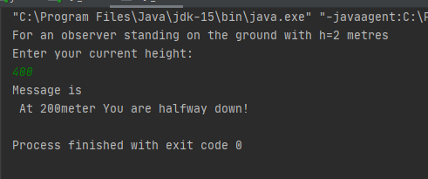

1. Write a recursive method for adding two numbers. Take the numbers from the user. Display the result in the caller method.

package com.company;  
import java.util.Scanner;  
public class Q1_b {  
 public static int sum(int x , int y){  
 if(x==0)  
 return y;  
 return (1 + *sum*( x-1 , y));}  
 public static void main(String[] args){  
 Scanner sc = new Scanner(System.*in*);  
 System.*out*.println("Enter 1st number: ");  
 int a = sc.nextInt();  
 System.*out*.println("Enter 2nd number: ");  
 int b = sc.nextInt();  
  
 System.*out*.println("Sum is: " + *sum*(a,b) );  
 }  
}

**Output:-**

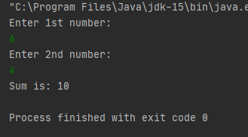

1. Take a number for user, say N, and pass it to a recursive method that will calculate the sum of all the numbers from 1 to N. Display the result in main().
   1. Example: N = 5
   2. Processing: 5 + 4 + 3 + 2 + 1
   3. Output: 15

package com.company;  
import java.util.Scanner;  
  
public class Q1_c {  
  
 public static int sum(int n){  
 if(n==1)  
 return 1;  
 return (n + *sum*(n - 1));  
 }  
 public static void main(String[] args){  
 Scanner sc = new Scanner(System.*in*);  
 System.*out*.println("Enter N (and you will get a Sum) : ");  
 int N = sc.nextInt();  
 System.*out*.println("Sum is: " + *sum*(N));  
 }  
}

**Output:-**

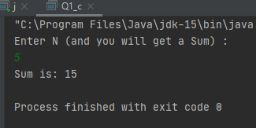

1. Write a recursive method that will take a number, say N, and display the pattern as follows: a. Example: N = 16
   1. Pattern: 16 11 6 1 -4 1 6 11 16
   2. Explanation: Subtract 5 from N each time and display the resulting number, until the number is zero or less than zero. After that, the reversed pattern is printed.

package com.company;  
import java.util.Scanner;  
  
public class Q1_d {  
 public static void RightSide(int n , int e){  
 if(n==e){  
 System.*out*.print(" " + n);  
 return;  
 }  
 System.*out*.print(" " + n);  
 *RightSide*(n+5 ,e);  
 }  
 public static void LeftSide(int n,int e){  
  
 if (n<=0){  
 *RightSide*(n,e);  
 return;}  
 System.*out*.print(" " + n);  
 *LeftSide*(n-5,e) ;  
 }  
 public static void main(String[] args){  
 Scanner sc = new Scanner(System.*in*);  
 System.*out*.print("enter N: ");  
 int N = sc.nextInt();  
 System.*out*.println(" Pattern is: ");  
 *LeftSide*(N,N);  
 }  
}

**Output:-**

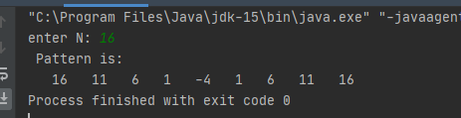

**Q – 2. Draw the class stacks of part b, c, and d.**

